OPERATING SYSTEMS AND SYSTEMS PROGRAMMING

Sec:- 2

Name:- Sai Sowseelya Vedula
RollNo:- 2520030260

Skill 1 & 2
- To Install Linux VM, Configure GCC, Setup Git Repository, Create Project Structure, Understand Shell Architecture, Build Initial Makefile
To Analyze process abstraction, execute fork(), understand exec() family, analyze parent-child relationships, inspect process tree, practice system call tracing

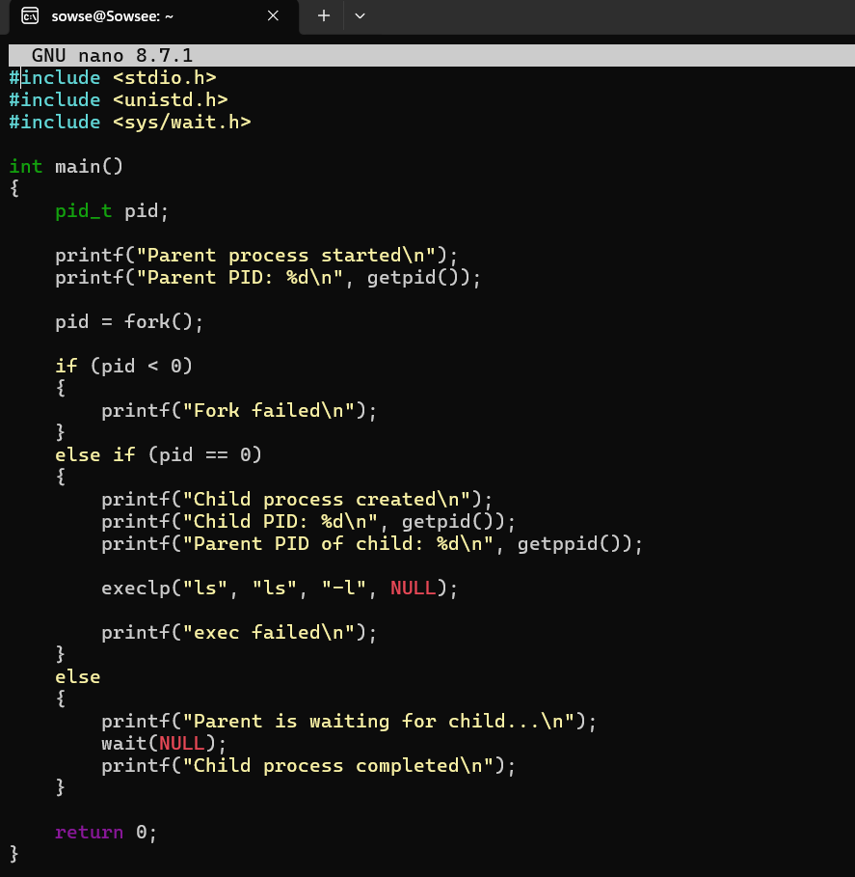
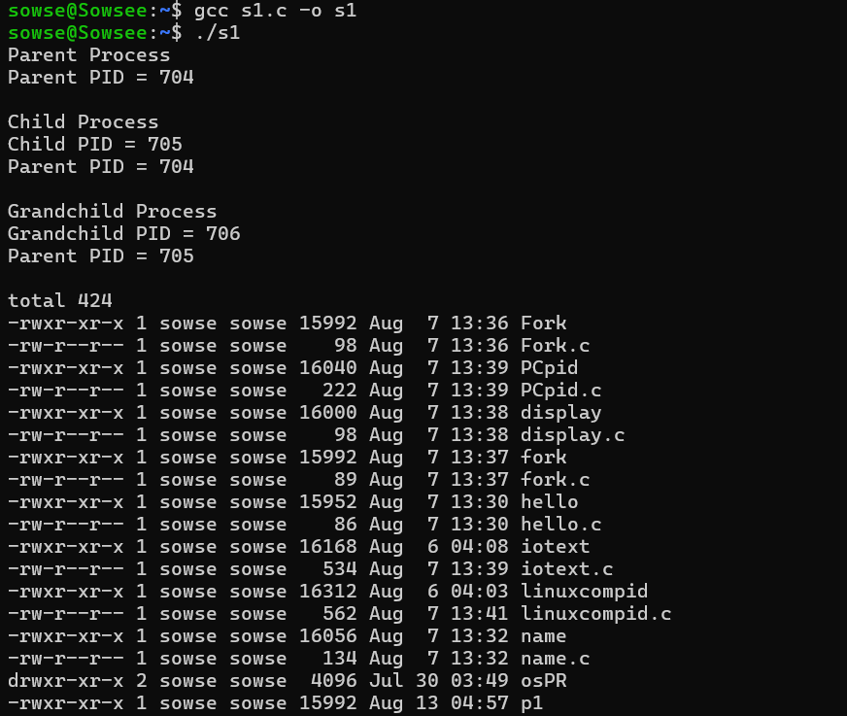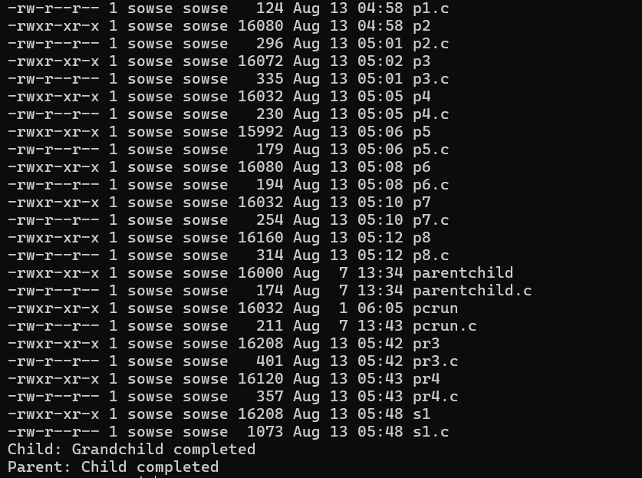

- To Create Main Loop, Display Prompt, Read User Input, Handle Exit Conditions, Design Control Flow Diagram, Test Interactive Loop
To Capture Keyboard Input, Handle Backspace, Process Enter Key, Manage Input Buffer, Support Multi-Character Commands, Test User Interaction
